Course: IS312 – Web Design and Programming

Quarter: Fall – 2022

Name: Trevor Sparks

**Task #1:**

I am noticing that I need to be more careful when I am writing code. This task took me a little while because I forgot the equal sign after Pizza when I was declaring and initializing the myPizza variable. It took me a little while to identify the error.

Task 1

**Task #2:**

**Task 2-1**

Task 2

**Task 2-2**

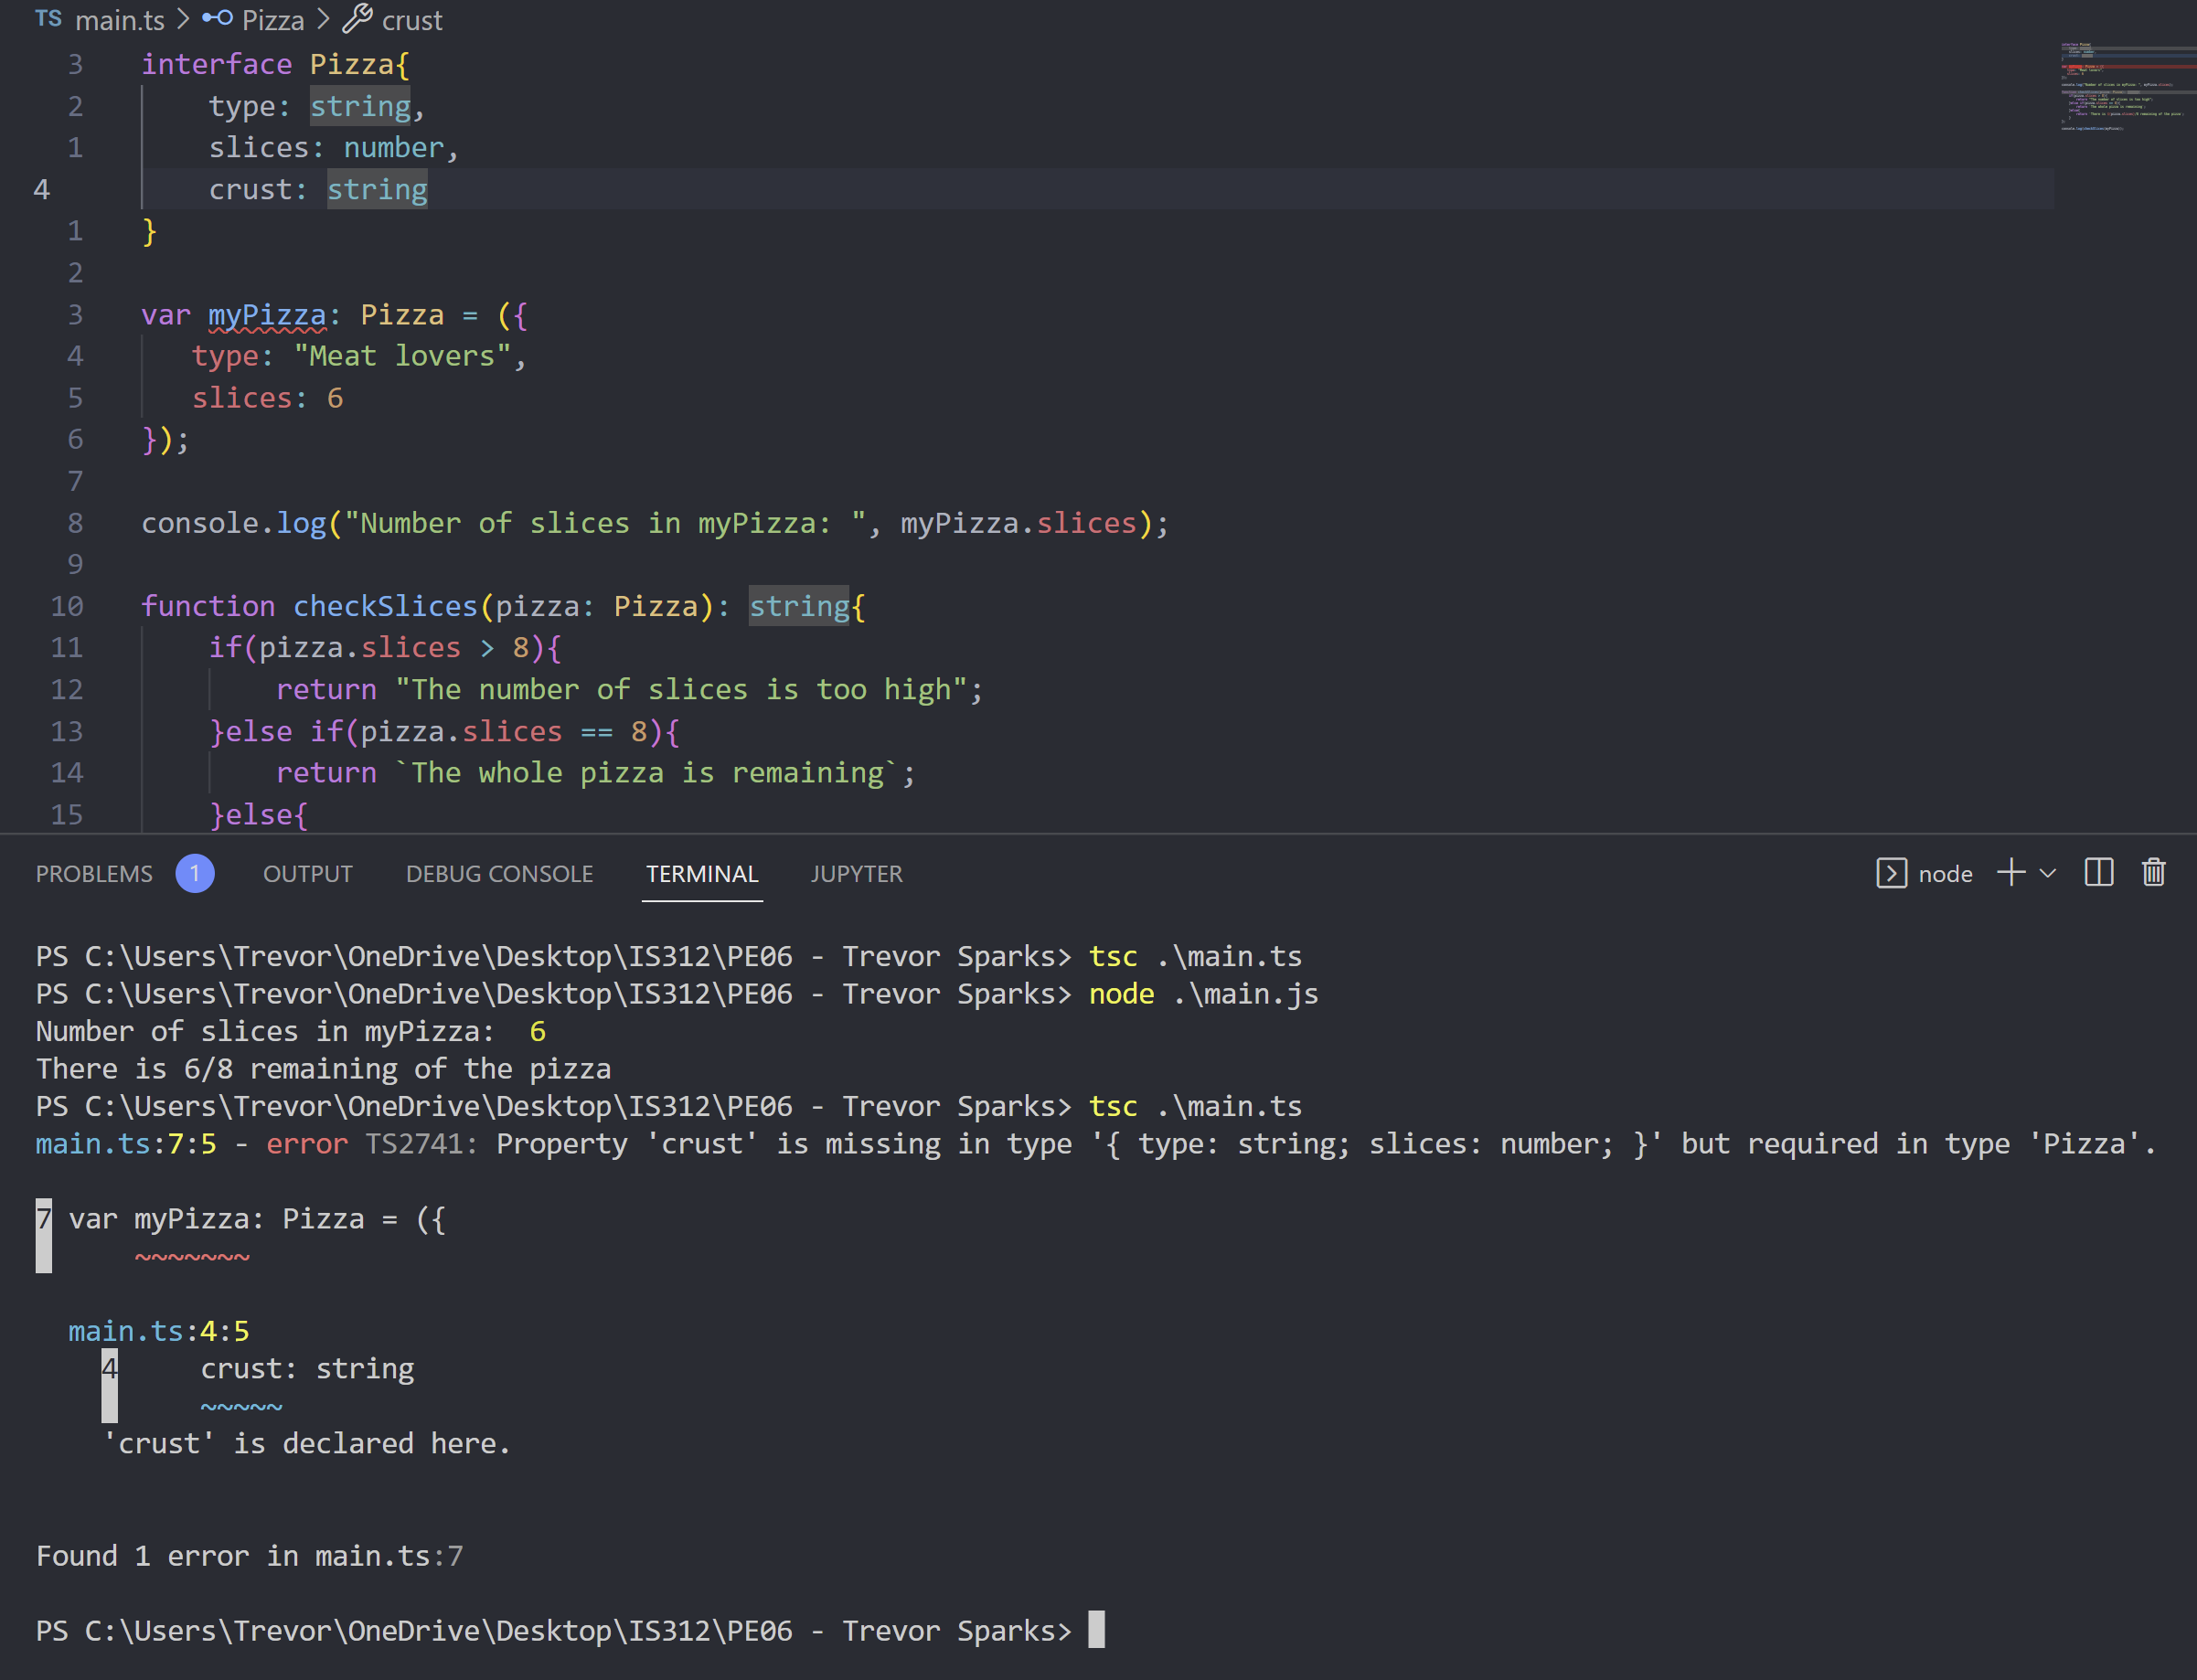

Task 2

We receive an error when attempting to initialize and declare the variable myPizza. The error is because the parameter crust is declared in the interface pizza, but we are not initializing it in the variable myPizza; once we make the crust parameter optional by adding the question mark, the error goes away.

**Task #3:**

**Task 3-1**

The first error I ran into when writing this code was that when the interface Toppings was written to extend the interface Pizza, the property crust was declared twice. In the Pizza interface, crust is optional and is of the type string, while in the Toppings interface, crust is not optional and is of type Boolean. To fix this code, I changed the type of crust in the Toppings interface to string because a pizza without crust is just sauce and cheese, and I also made it optional.

Task 3 -

When I changed myPizza to a variable type Topping, I ran into a compilation error. The problem is that myPizza does not have parameters pineapple or parmesan. It also does not have crust, but that parameter is optional.

When I updated my checkSlices function to accept the Topping interface, nothing happened. The code compiled without problem and worked just fine. Nothing needed to be changed; the output was the same as when I passed it to the pizza interface. There was no problem because the only parameter the checkSlices function is using slices, which is supplied in the Pizza interface, not the Toppings interface.

**Task #4:**

This week's programming exercise was a good lesson in patience. When I first started working on this assignment, I ran into a problem with task #1. I forgot to add an equal sign when declaring and initializing the variable myPizza. Below is a screenshot that shows where I forgot to put the equal sign (Task 4 1). The resulting error message from the compiler told me that there was a problem when I was declaring the myPizza variable; however, beyond that, all it said what that the compiler was expecting a ','. Not super helpful, I have attached a screenshot of that error as well (Task 4 2).

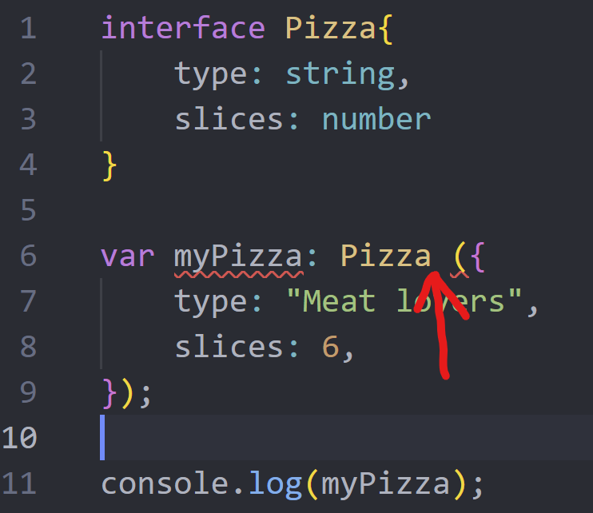

Task 4

Task 4

Other than that problem, I had no issues with this assignment. The rest of the assignment was straightforward and was completed without issue.